**Introduction to an Amazon Linux Amazon Machine Image (AMI)**

## Accessing the AWS Management Console

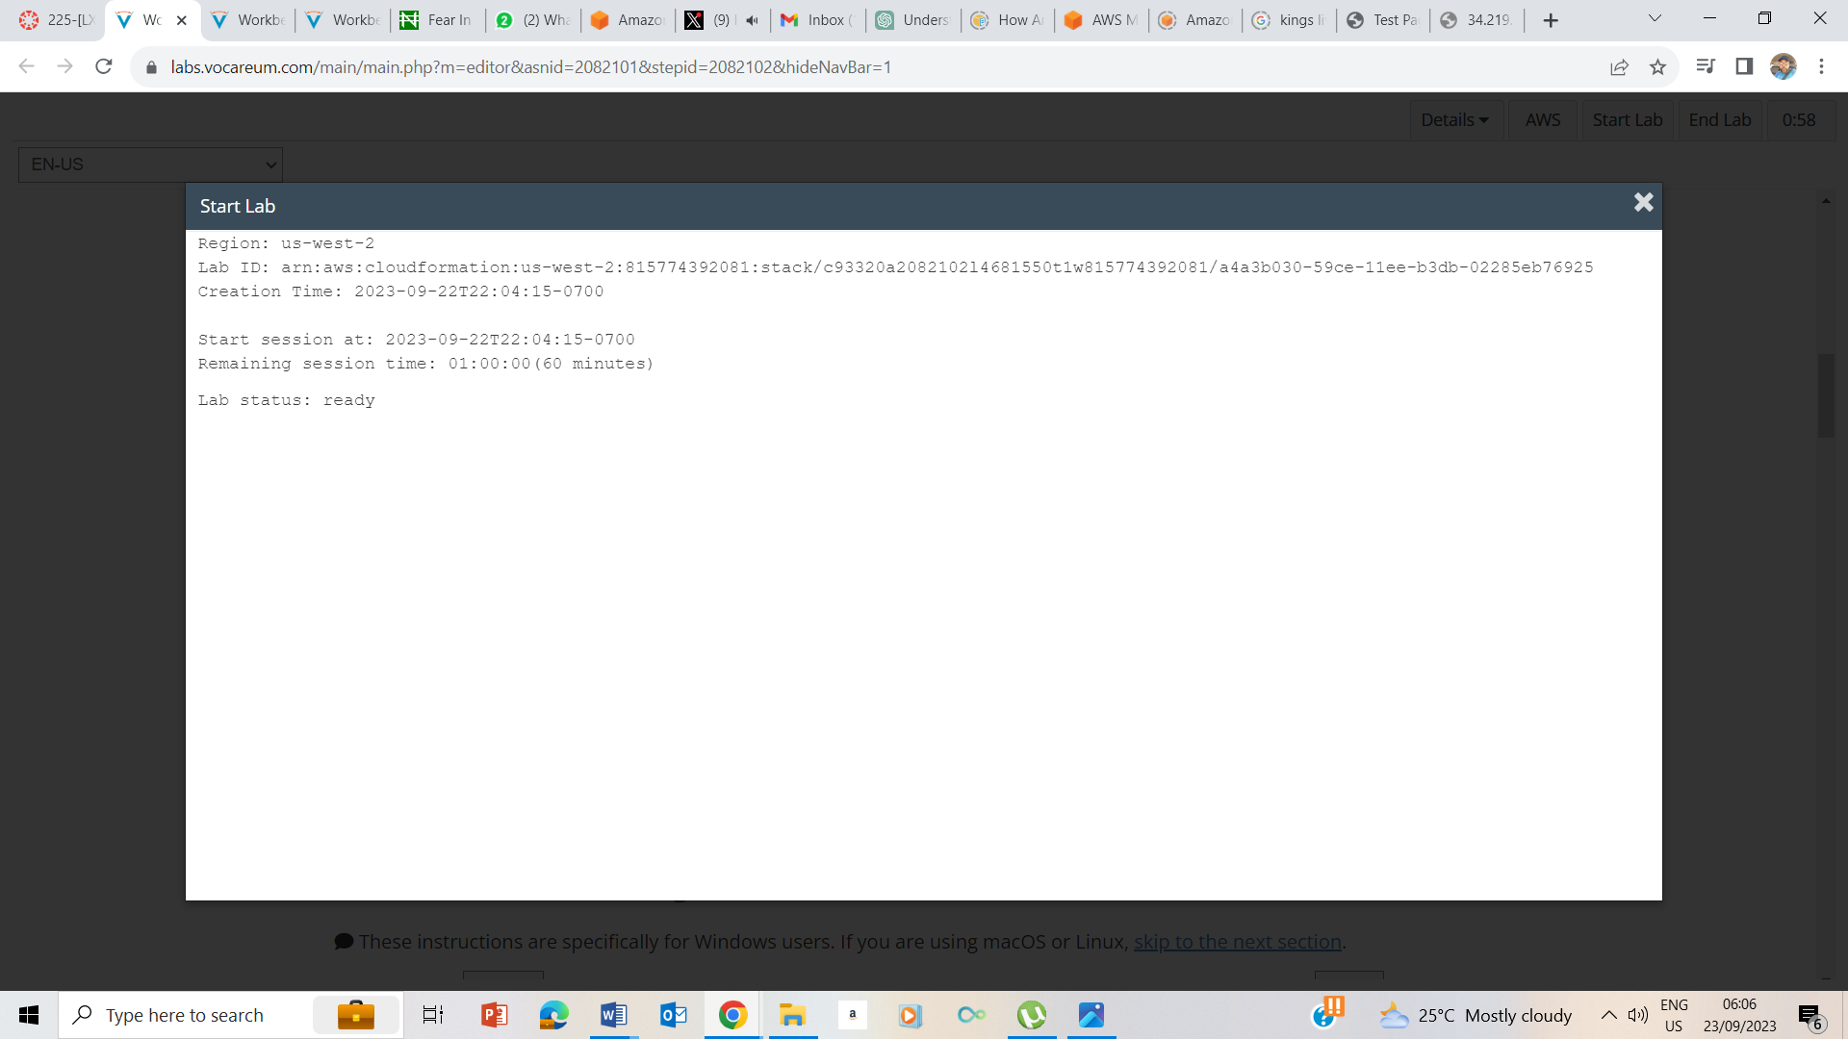

1. Start Status - Ready

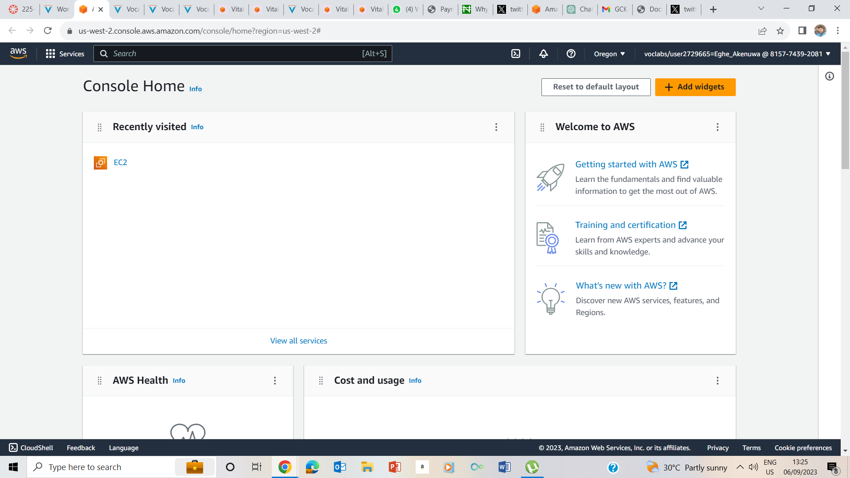

1. Clicked on AWS to take me to the AWS management console.

## Task 1: Use SSH to connect to an Amazon Linux EC2 instance

### Windows Users: Using SSH to Connect

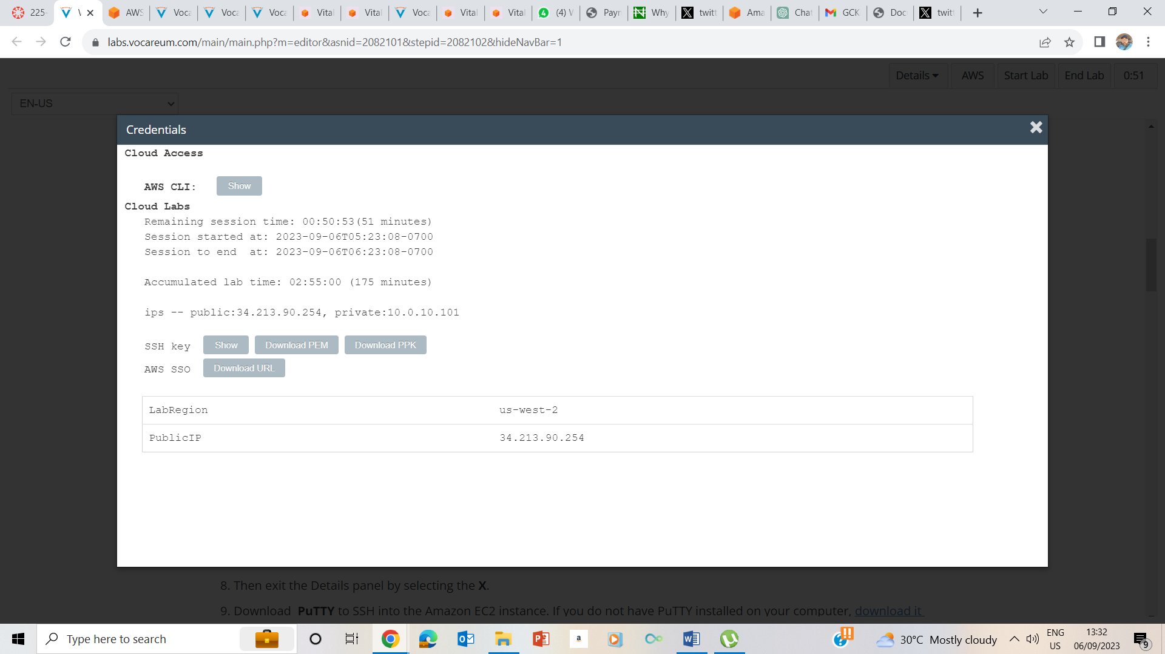

5. Clicked on Details Dropdown Box and show. I made note of the Public IP address and also downloaded PPK button.

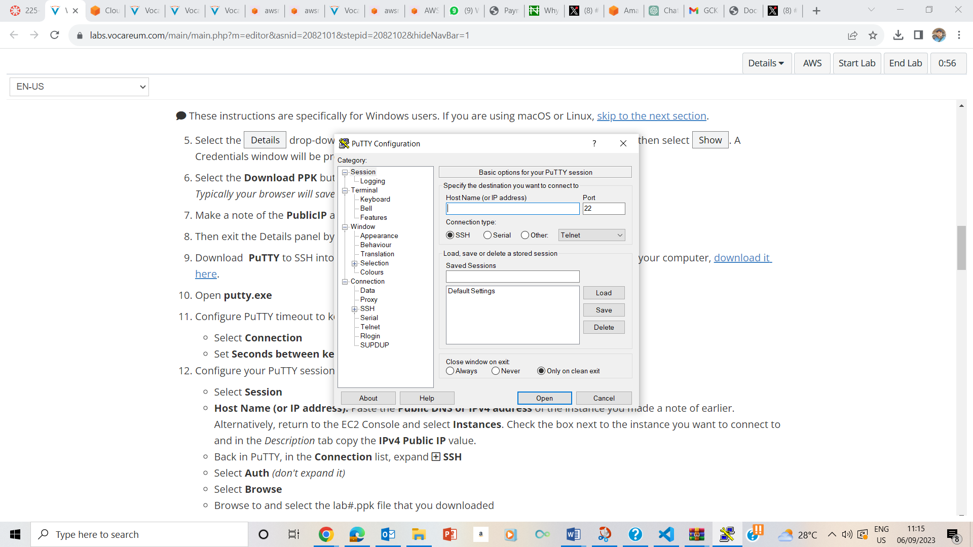

9-10 I downloaded Putty , opened putty.exe to run the putty file

RUNNING PUTTY.EXE

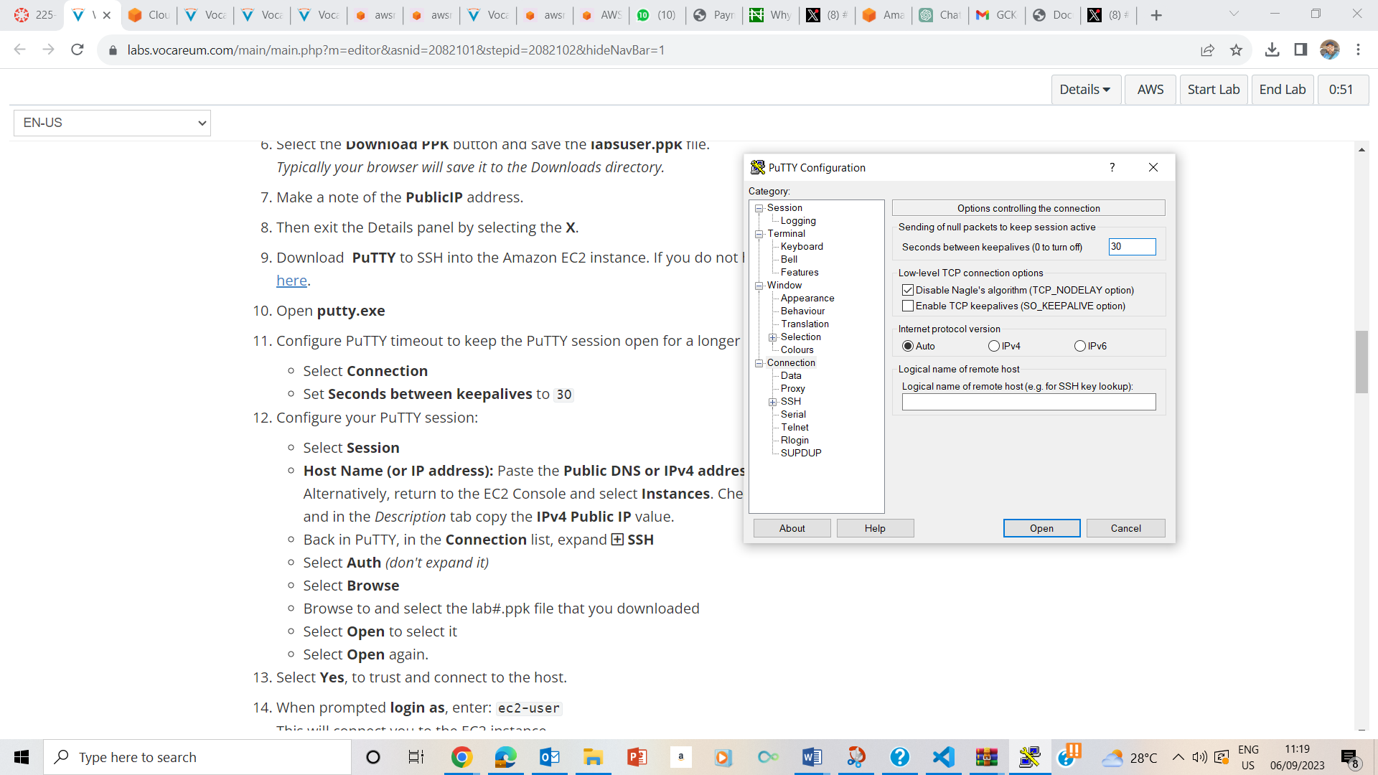

11 I select Connection and set the seconds between keepalives to 30

Configuring PUTTY to keep sessions alive for longer periods i.e. 30 Seconds

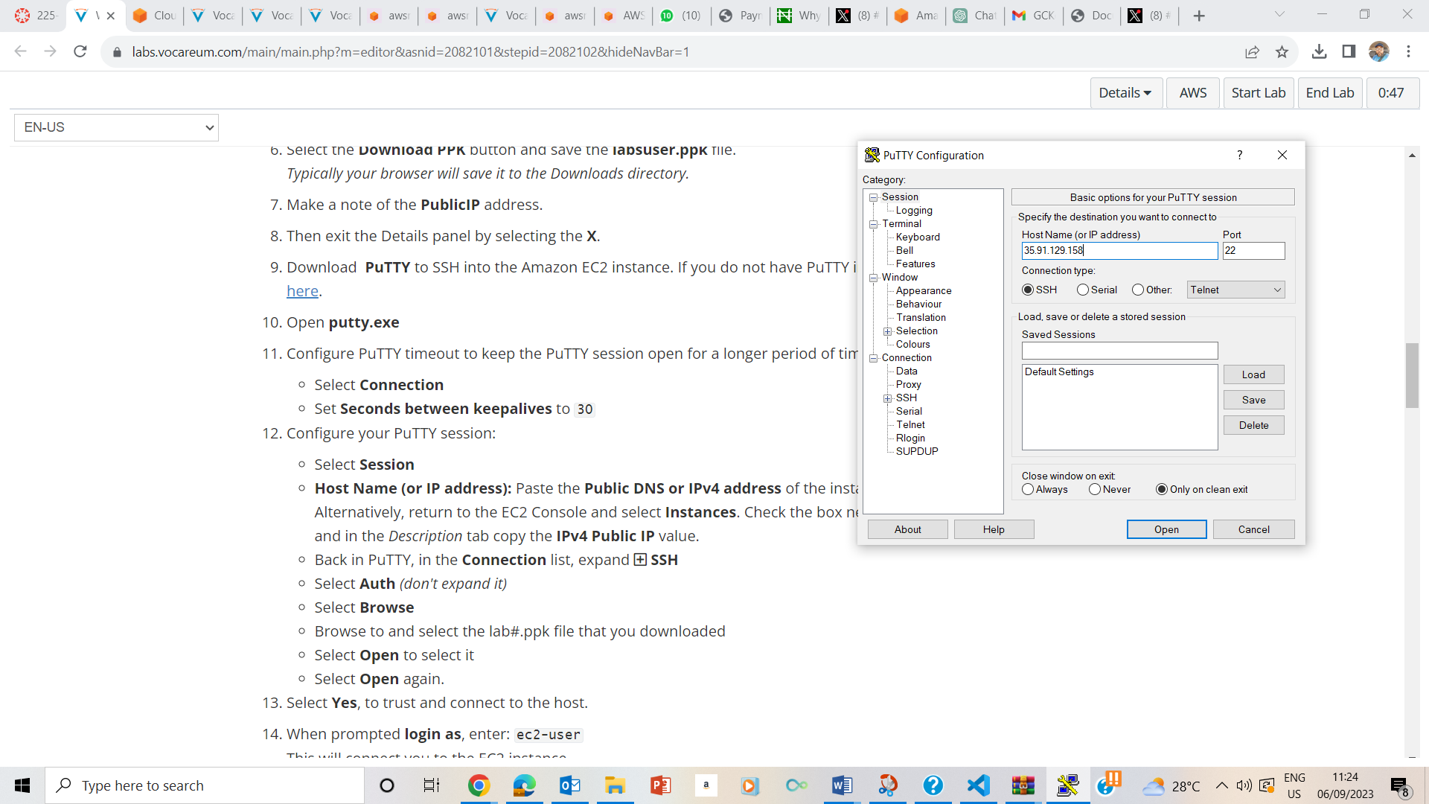

Inputting the IP address into the session.

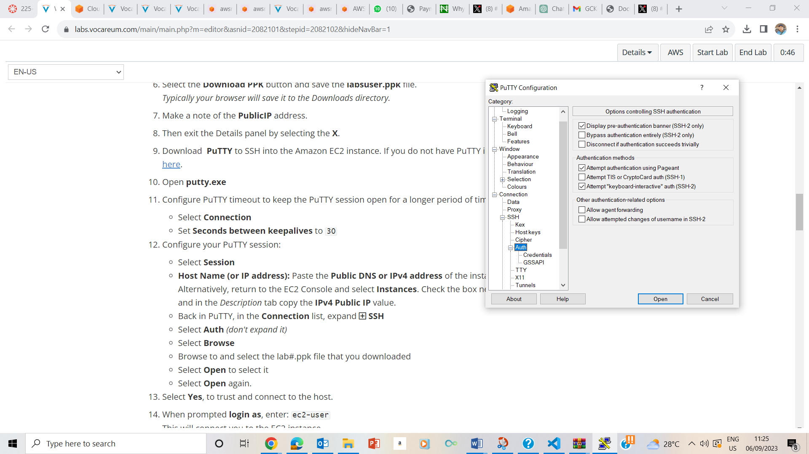

Expansion of SSH

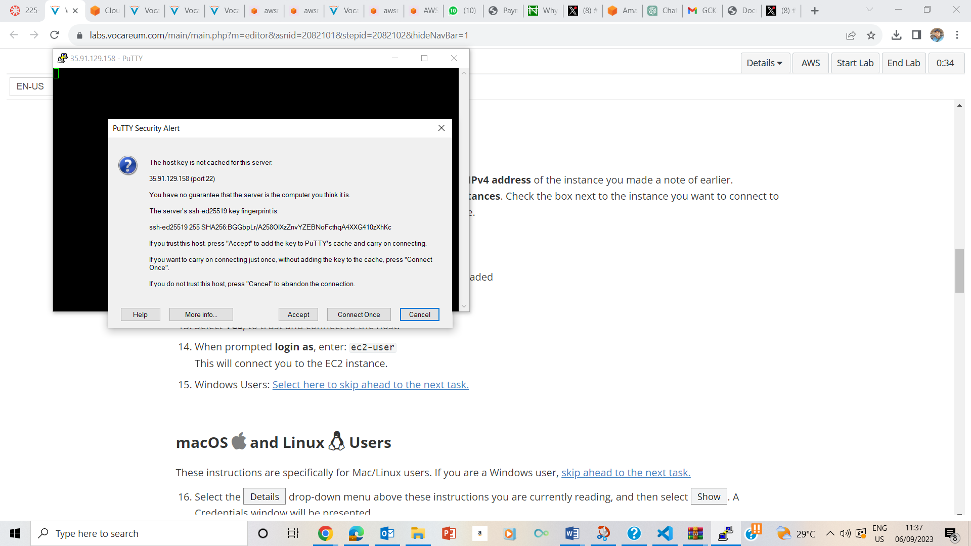

Accepting the connection

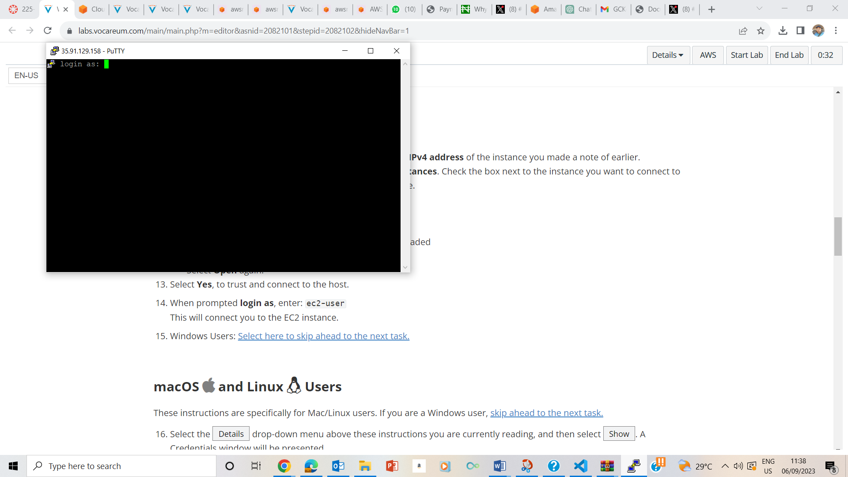

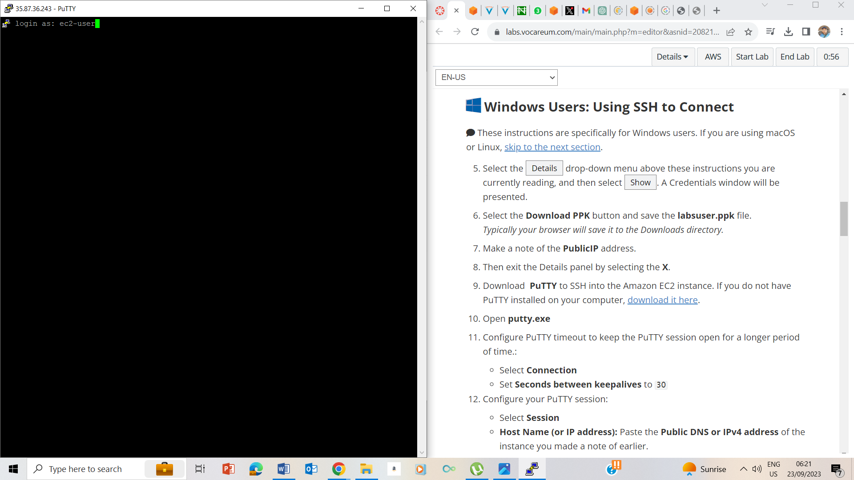

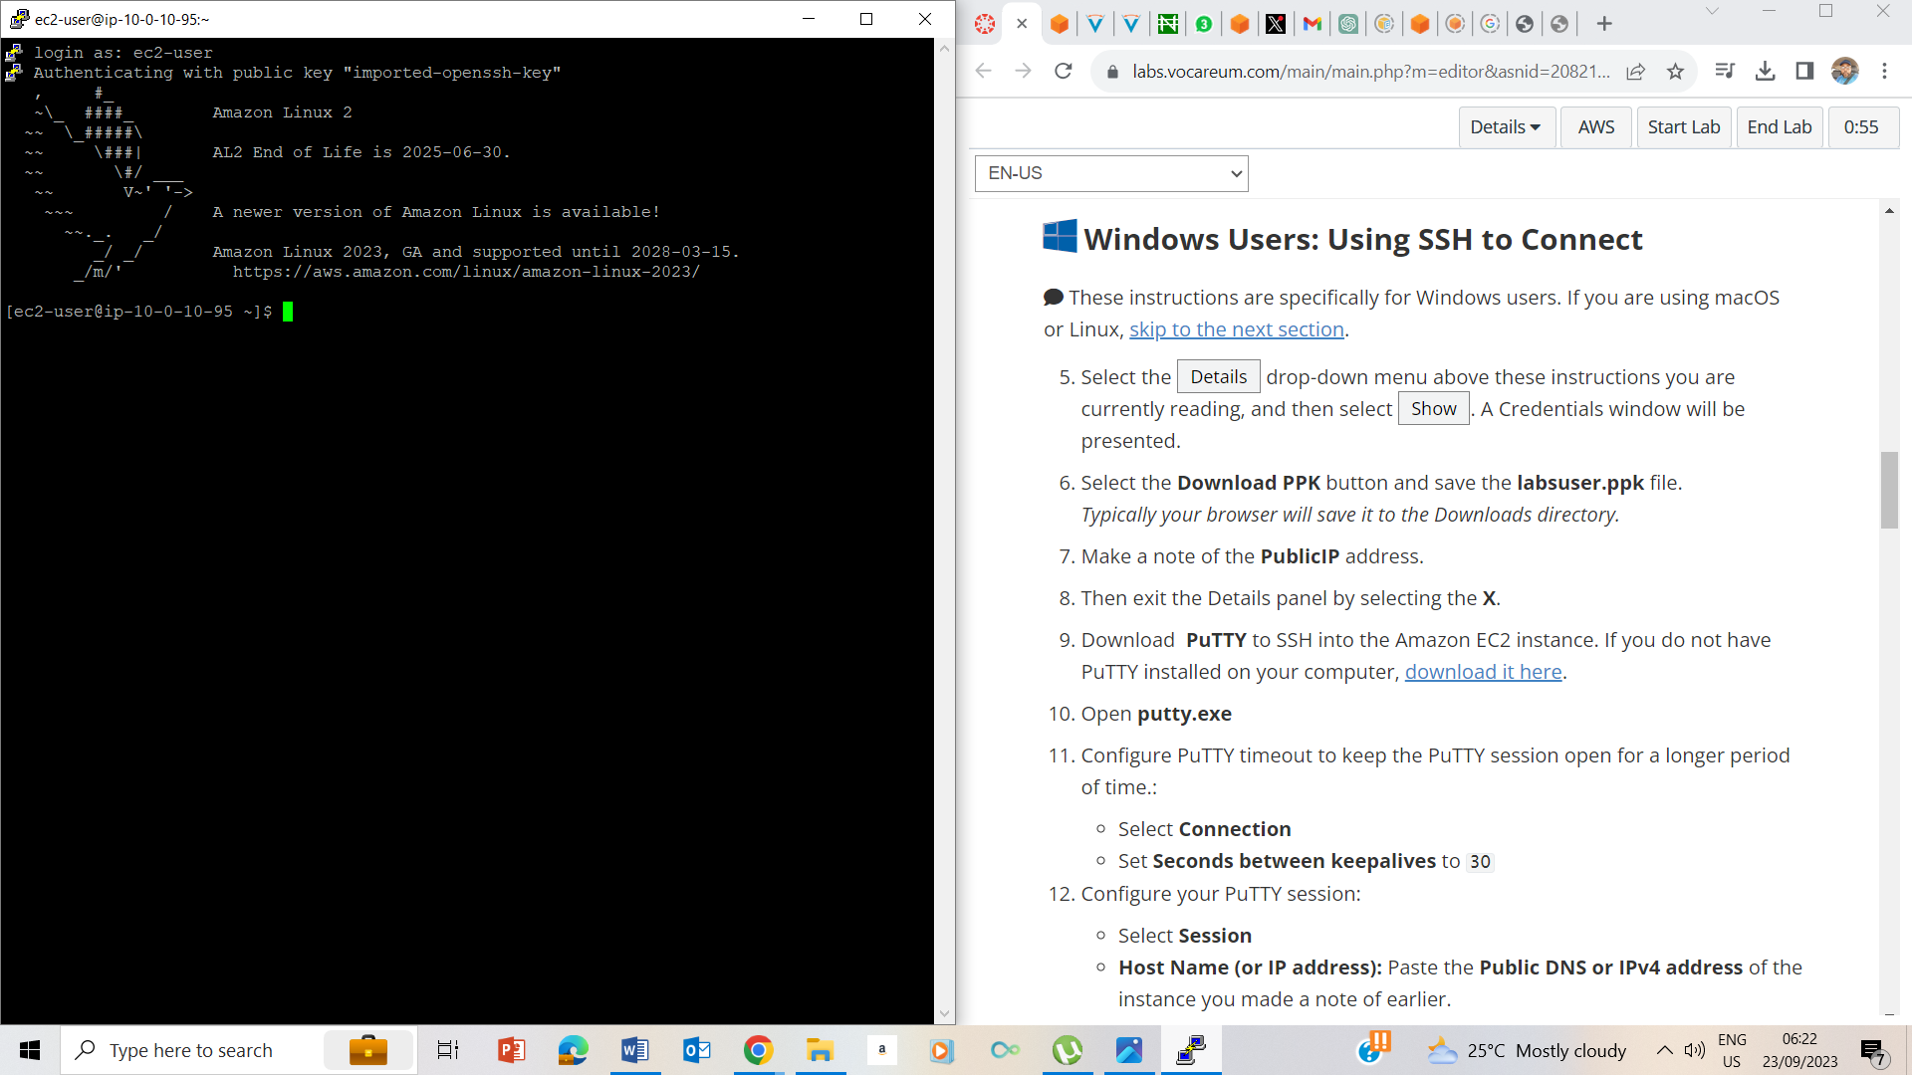

Entered user as ec2-user

## Task 2: Exercise - Explore the Linux man pages

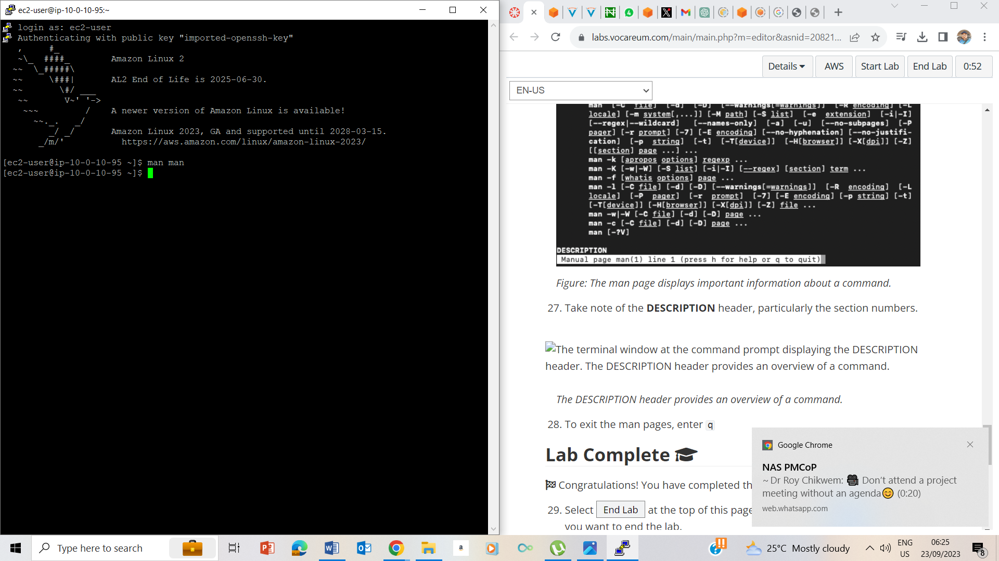

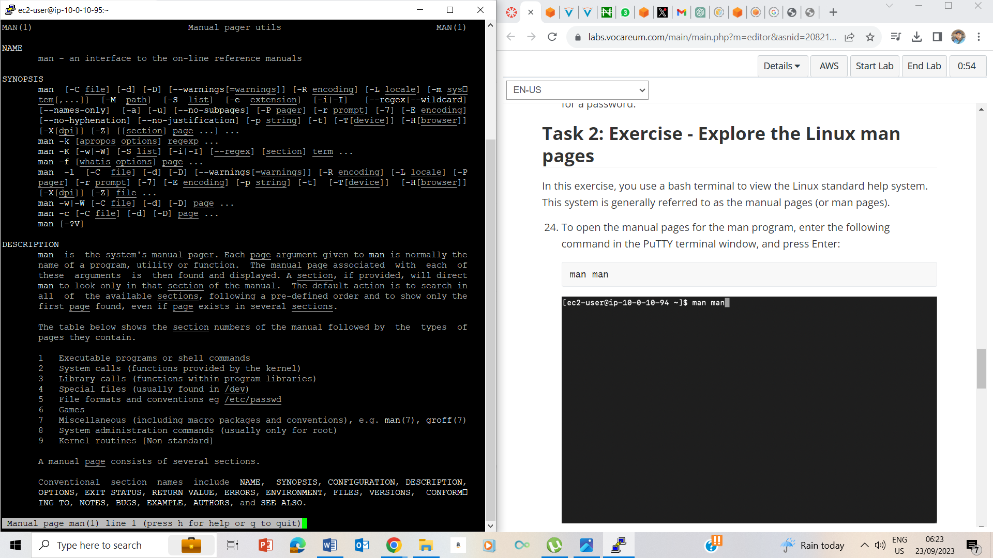

24. I entered the command man man

27. I also took note of the DESCRIPTION header.

## Lab Complete

